DT-ENG-DX471/TD7-V1 / 201904

2 WIRE HOME Wi-Fi SYSTEM

DX471-TD7

7" COLOR TFT Wi-Fi MONITOR

· Please read this manual carefully before using the product you purchase,and keep it well for future use.
· Please note that images and sketch maps in this manual may be different from the actual product.
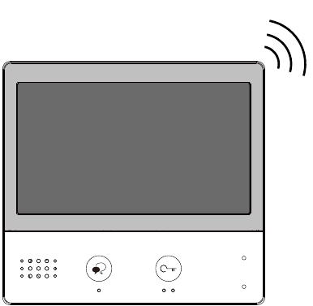

Contents
1.Parts and Functions .................................................. 1
2.Mounting ................................................................... 2
3.Main Menu ................................................................ 3
4. Answering a Call ...................................................... 5
5.Panview & Zoom ....................................................... 6
6.Monitoring ................................................................. 6
7.Call Another Rooom or Apartment(Intercom) ............ 8
8.View Call Record....................................................... 10
9.Open Staircase Light................................................. 11
10.No Disturb Function ................................................ 12
11.Divert Call ................................................................ 13
12.Setting ..................................................................... 14
Enter setting interface .......................................................14
Ring tone setting ...............................................................15
General setting..................................................................15
Installer setting ..................................................................19
Wireless setting.................................................................26
About ...............................................................................31
13.Download Setup 2Easy APP................................... 32
14.Surveillance door station via 2Easy APP ................ 34
15.How It Works ........................................................... 34
16.Specification............................................................ 36
17.Precautions ............................................................. 36

1. Parts and Functions

LCD Screen

Speaker

Talk/Mon Button

POWGNDRINGSW-SW+

Power/No Disturb Indicator
Microphone
Unlock Button

ON
DIP

123456
Connection port

L1
L2

Key functions

-1-
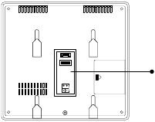

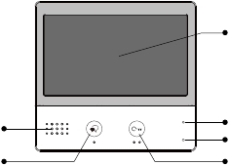

Speaker | Send out vioce from the visitor.
Talk/Mon button | Press to communicate hands free with visitor;Press to view the outdoor condition in standby mode.
LCD screen | Display the visitors' image.
Power/No Disturb indicator | Show the power status of the system.Show the no disturb status.
Microphone | Transmit audio from one station to other stations.
Unlock button | Press to release the door.
Connection port | Bus terminal, Setting the monitor's address.

Terminal description

SW+,SW-: Extra door bell call but-
ton connection port.

POW GND RING SW- SW+

Ring,GND: Extra buzzer connec-
tion port.
ON DIP
123456

SD

POW,GND: 12~16V extra power
connection port.
DIP switches: Total 6 bits can be
configured.
Bit1~Bit5: User Code setting
-37·
switch.
Bit6: Video impedance matching
-37·
switch.

L1

L2

USB-Wi-Fi adaptor

L1,L2: Bus line terminal.

2. Mounting

Mounting box

The unit

Mounting screw
x 2(included)
2 wire cable
Mounting bracket
The installation height is suggested to 145~160cm.
1. Use screws to fasten the mounting bracket to the wall with mounting box.
2. Connect the 2 wire cables to the unit.
3. Mount the unit to the mounting bracket, make sure the unit is absolutely
attached to the mounting bracket.

-2-
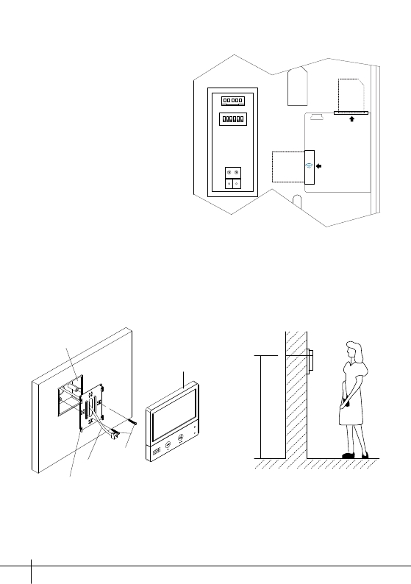

145~160 cm

3. Main Menu
The Main menu is your starting point for using all the applications on your moni-
tor.
Touch Unlock button, or touch anywhere of the screen on monitor in standby
mode, the Main menu will appear as follow:

Monitor
Touch it to view outdoor condition.

Touch this icon to directly
enable the indicated function.

Intercom
Touch it to enter intercom
selections.
Call Record
Touch it to see calling in/calling
out records or missed calls .

Current date and time.
Touch it to enter the date
time set interface.
Status bar
Light
Touch it to light up the
staircase light via RLC.

SIP config
Touch it to enter SIP
config interface.

Wi-Fi status
Touch it to enter
Wireless setting
options.

Setting
Press it to enter setup interface.
Close
Touch it to turn off the screen
and make the monitor in standby
mode.

Call Scene
Touch it to activate the
functions of No disturb, Divert
call.

Function status

-3-
Icon | Meaning | Description
 | Missed call | Display when there is missed call unread.Touch it to review the missed call in shortcut.
 | No disturb | Display when activate the functionTouch it to enter Call Scene interface in shortcut.
 | Call transfer
 | SIP server connection active and configured | Touch it to enter SIP server information interfacein shortcut.
 | SIP server connection disabled
 | SIP server connection active andnot connected

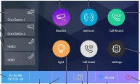

While talking with a door station

Displays which door station
is calling.
Shows status of talking, unlocking
ect.
Red while recording.

Displays talking time.
00:10
Door Station1

5 direction pad button,
zoom&pantilt the picture.

Note: The 5 direction pad operation should make effective with fish-eye door station.

-4-
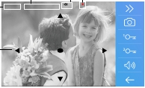

Icon | Meaning | Description
 | Wi-Fi connection active and notconnected | Touch it to enter Wi-Fi setting interface in shortcut.
 | Wi-Fi connection disabled | Touch it to enter Wi-Fi setting interface in shortcut.
 | Wi-Fi connection active and configured | Touch it to enter Wi-Fi setting interface in shortcut.

4. Answering a Call

1. Touch it to answer the call.

To end the call touch it again.

2. If necessary, during the call
touch it to display the audio/
video adjustment icons.

3. Touch it to record image/
video.

4. Touch the icons to adjust
00:10
Door Station1

the parameters you want.
00:10
Door Station1

5

3
6
Adjust the image colour.
Adjust the image brightness.
Adjust the volume.

5. Touch it to open the door

lock for visitor.
00:10
Door Station1

The door lock key display
on screen briefly, to indicate
that the door lock has been
released.

-5-
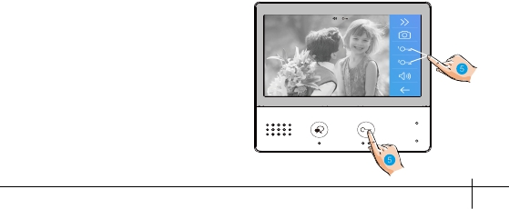

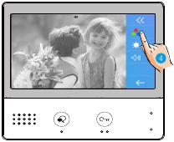



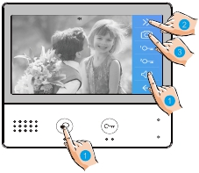

5. Panview & Zoom

If wants to see greater detail about visitors,move to the desired position by

touching
on the screen to view the image in pantilt & zoom mode.

1. Touch it to activate the panview
and zoom function.

00:10

Door Station1

6. Monitoring

This section can be used to monitor your home by enabling one of the cameras
inside the apartment, the common areas (e.g. garages, garden), and at the
entrance.

1. Touch it to display the cameras
in your system.

-6-
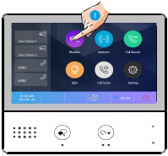

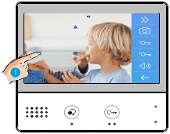

2. Touch it to activate the desired
camera on Monitor interface .

3. It is possible to “>” (display in
sequence) the other cameras.

4. Touch it to return the previous
menu.

5. Touch it to activate the specified
camera in shortcut.

The display shows the images recorded by the active camera.
6. If the camera belongs to an

Door Station, touch it to activate
00:10
Door Station 2

audio communication.
Touch it again to return the
Monitor interface .

-7-
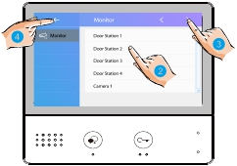

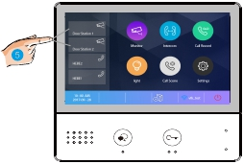

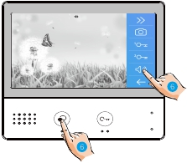

7. Call Another Room or Apartment (Intercom)

It is possible to communicate with another device installed in another room of the
apartment or with a device of another apartment.

1. Touch it to display the available
intercoms.

2. Touch it to display the available
namelist calls.

3. Touch it to activate the
communication with the desired
intercom.

Intercom

Namelist

Intercom
Namelist
Inner Call
Guard Station
Input Numbers
Namelist
HEBE 1
HEBE 2
HEBE 3
HEBE 4

HEBE 5

the call is active.

-8-
00:15
HEBE 1
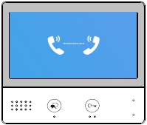

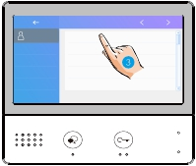

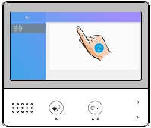

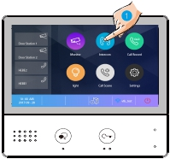

4. Touch it to activate the

communication with another room.

Intercom
Intercom
Namelist

Inner Call
Guard Station
Input Numbers

5. Touch it to activate the

communication with guard station.

Intercom
Intercom
Namelist

Inner Call
Guard Station
Input Numbers

6. If the system does not have the

room number you want, you can enter
Intercom

other room number. Touch it to enter
input numbers interface.
Intercom
Namelist
Inner Call
Guard Station
Input Numbers

-9-
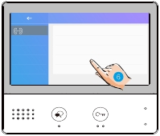

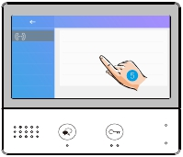

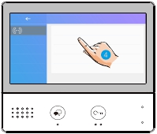

7. Input the room numbers you want.
123_

Note: when a call is received from the Door Station while the internal unit is in “intercom”
mode, the system follows the priority rules and ends the active call.

8. View Call Record

When there are one or more unread call records in the answering machine,
clicking the icon shows them.

1. Touch it to enter call record interface
and display the records. These records
include missed calls, incoming calls,
outgoing calls and playback.

2. Touch it to show the missed calls.
Missed call list:

-10-

Calling date&time
Calling source
Missed
Incoming
Outgoing
Playback
[2017/09/16 09:50] Door Station 1
[2017/09/16 11:25] Door Station 1
[2017/09/17 13:50] Door Station 2
[2017/09/17 18:37] Door Station 1
[2017/09/18 08:52] Door Station 2
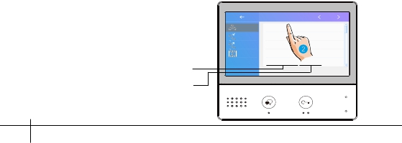

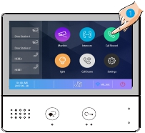

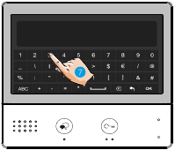

The infomations you select is played back automatically.

3. Touch it to scroll interface.
1/223
4. Touch it to delete the image.

[2017/09/16 09:50] Door Station 1

9. Opening Staircase Light

Note: The staircase light should be connected on the system, and this function
should be supported by RLC. Please refer to RLC user instruction in detail.

1. Touch it to open the
staircase light.

-11-
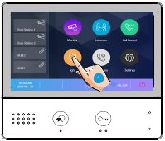

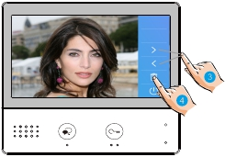

10. No Disturb Function

If you don’t want to be disturbed, for example, at night. Activating the mute
function is necessary for you.

1. Touch it to enter call scene interface.

2. Touch it to set the no disturb mode: No

Disturb 8H and No Disturb Always.

CallScene
CallScene
Normal Use

No Disturb 8H
No Disturb Always
Divert Call If No Answer
Divert Call Always

No Disturb 8H: The calling from door station or other monitors will be forbidden for 8
hours.
No Disturb Alaways: The calling from door station or other monitors will be forbidden all
the time until the function is released.

Note:
* The no disturb indicator turns from green to red, to indicate that the no disturb function
has been activated.
* This function will perform immediately if selected,and the status bar on main menu

-12-
interface will show "
" icon.

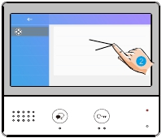

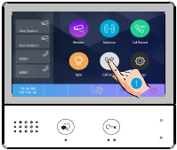

11. Divert Call

The calling from door station can be diverted to your phone. please note that this
function should be supported by Wi-Fi or SIP network.

1. Touch it to enter call scene interface.

2. Touch it to set the divert call mode:

Divert Call If No Answer and Divert Call
CallScene

Always.
CallScene
Normal Use
No Disturb 8H

No Disturb Always
Divert Call If No Answer
Divert Call Always

Divert Call If No Answer: If nobody answers the call in 30s when receives call from
door station, diverts the call to the smart phone.
At this mode,the monitor will always open the screen and show image from door station
during diverted, if the monitor answers the call at this time,diverted will conclude at once.
Divert Call Always: When receives call from door station, diverts the call to smart phone
directly.
At this mode, the monitor will shut off the screen after diverting successfully, but you can
still use it in normal.
Note:
* If divert the call to smart phone via Sip sever, need to choose one.
* This function will perform immediately if selected,and the status bar on main menu

interface will show "
" icon.

-13-

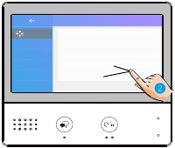

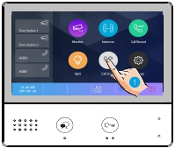

12. Setting

Enter setting interface

1. Touch it to enter setting interface.

Call tune

Call Tune
General
Installer
Wireless
About
Ring volume
Ring time
Door1 calling tune
Door2 calling tune
Door3 calling tune
[04]
[35s]
[01]
[01]
[01]

2. Touch the icon for the desired customisation, choosing among:

-14-

Call Tune
General
Installer
Wireless
About

Ring volume - Ring time - Door1/2/3/4 calling tune - Doorbell calling tune -Intercom calling
tune -InnerCall calling tune -GuardCall calling tune
Date and time -Language -Monitor time -Shortcut setting -SD card - Screen on in divert -
Restore to default
Current address -Intercom enable - IPC Setting - Monitor lisht manage - System setting - FW
upgrade - Unlock time - Unlock mode - Auto reboot - Reboot
Wi-Fi switch -Wlan setting -Wireless device regist - SIP config - SIP tools
All kinds of device information
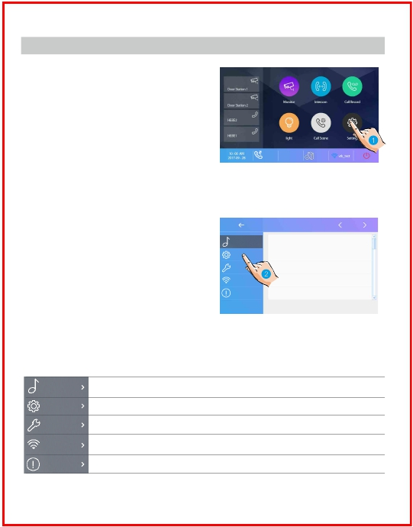

Ring tone setting

The ring call tone can be set individually to distinguish different calling sources.
Total 22 tones can be selected.
Scroll to next interface

1. Touch it to enter call tune setting
interface.

2. Touch the setting item to select the
call tone.

Call Tune
General
Installer
Wireless
About
Call Tune
Ring volume
Ring time
Door1 calling tune
Door2 calling tune
Door3 calling tune

[04]
[35s]
[01]
[01]
[01]

Ring volume: adjust the ringtone volume.
Ring time: adjust the ringtone time.
Door1/2/3/4 calling tune: call tone from door1/2/3/4 entrance panel.
DoorBell calling tune: call tone from doorbell.
Intercom calling tune: call tone from an intercom of another apartment.
InnerCall calling tune: call tone from an intercom in your apartment.
GuardCall calling tune: call tone from the Gurad unit.

General setting

This section contains the general settings and device information.

1. Touch it to enter general setting
interface.

Call Tune

General
Date and time

General
Installer
Wireless
About
Language
Monitor time
Shortcut setting
SD card
[000]
[300]

-15-
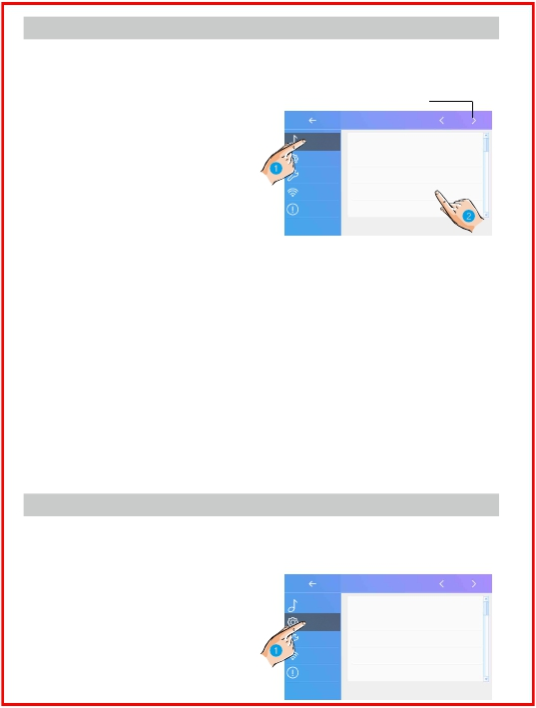

Date and time setting
The current date and time can be modified at any time.

General

Date time set

Call Tune
General
Installer
Wireless
Date and time
Language
Monitor time
Shortcut setting
General
Date mode:
Time mode:
Date:
Time:
MM_DD_YYYY
HOUR_12
xxxx_xx_xx
xx:xx

About
SD card

1. Touch it to enter the date time set interface.
2. Touch it to select the item you want to change.
Date mode: 2 display mode: month/date/year and date/month/year
Time mode: 2 display mode: HOUR_12 and HOUR_24.
Date: touch it to set the date .
Time: touch it to set the time.
Time zone: touch it to set the time zone in your country.
Time auto update: Disable: should set the time manually. Enable: can synchronize the
system time

Changing the display language
The default language can be customized. But you can change it to your desire
language at any time.

General

Language

Call Tune
General
Installer
Wireless
About
Date and time
Language
Monitor time
Shortcut setting
SD card
General
[000]English
[001]Franch
[002]German
[003]Spanish

1. Touch it to enter the language interface.
2. Select the target language, and then touch it to confirm.
*If the target language is not found in the window, touch > icon to scroll next interface.
-16-
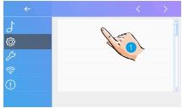

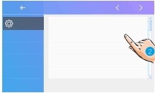

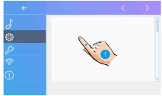

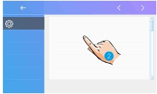

Setting monitor time
The monitor time can be changed at any time. It’s available to set 30s, 60s, 90s,
120s, 150s, 180s, 210s, 240s, 270s, 300s.
* 30s is the default monitor time.

General

Monitor time select

Call Tune
General
Installer
Wireless
About
Date and time
Language
Monitor time
Shortcut setting
SD card
General
30(s)
60(s)
90(s)
120(s)
150(s)

1. Touch it to enter the monitor time select interface.
2. Select the monitor time you want, and then touch it to confirm.

Shortcut setting
In this section it is possible to select the 4 quick actions that will appear on the
home interface.

General

Shortcut set

Call Tune
General
Installer
Wireless
About
Date and time
Language
Monitor time
Shortcut setting
SD card
ShortcutSet1
ShortcutSet2
ShortcutSet3
ShortcutSet4
Remove shorcut
Monitor list
Namelist
Inner Call
Guard Station

1. Touch it to enter the shortcut set interface.
2. Select the shortcut set item you want.
3. Select the type of function for which you want to add a quick action.
4. Remove the quick action from the home interface.

-17-
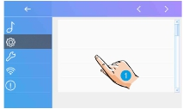

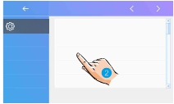

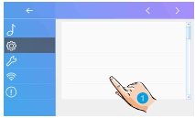

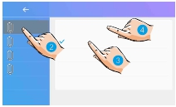

SD card
If the device insert an SD card, the SD card info can be reviewed on the device.

General
SD Card

Call Tune
General
Installer
Wireless
About
Date and time
Language
Monitor time
Shortcut setting
SD card
General
SD information
Copy image

1. Touch it to enter the SD card interface.
2. Select the item you want, and then touch it to confirm.
SD information:SD card capacity.
Copy image: touch it to copy the recorded images to SD Card.

Screen on in divert
When the monitors set to "Divert call always" mode, in default mode, when
receive a calling, the monitors' can not display the image. But the settings can
be changed,you can set the monitors to panel on at the same time when divert a
call.

General
General

Call Tune
General
Installer
Wireless
About
Date and time
Language
Monitor time
Shortcut setting
SD card
Call Tune
General
Installer
Wireless
About
Screen on in divert
Restore to default
[Disable]

1. Touch it to scroll to next interface.

Screen on in divert

-18-
2. Touch it to enter the screen on in
divert interface.
3. Select the item you want, and then
touch it to confirm.
General
Disable
Enable
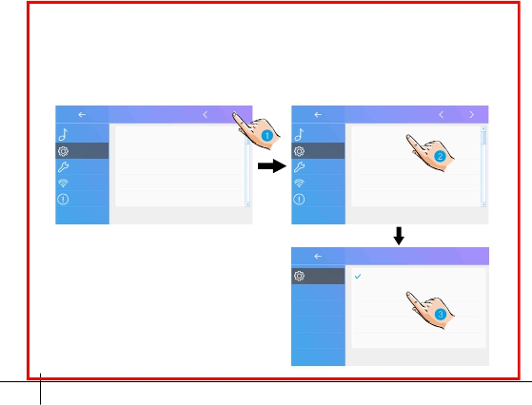

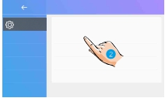

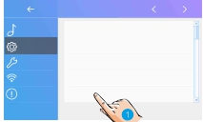

Restoring to default setting
The restore to default function allows the user to recover the settings to factory
setting.

General
General

Call Tune
General
Installer
Wireless
About
Date and time
Language
Monitor time
Shortcut setting
SD card
Call Tune
General
Installer
Wireless
About
Screen on in divert
Restore to default

1. Touch it to scroll to next interface.

Restore to default

2. Touch it to enter the restore to default
interface.
3. Select the item you want, and then
touch it to confirm.
General
Clear call record and pictures
Clear Wi-Fi settings
Restore general settings
Restore installer settings
Restore factory default

Notes: It has five items:Clear call record and pictures, Clear Wi-Fi settings,
Restore general settings, Restore installer settings, Restore factory default.

Installer setting

This section contains the device address setting and system settings.

1. Touch it to enter installer setting
interface.

Call Tune
General
Installer
Wireless
About

Installer
Current addtess
Intercom enable
IPC Setting
Monitor list manage
System settings

[01]
Enable

-19-
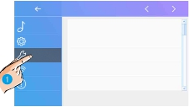

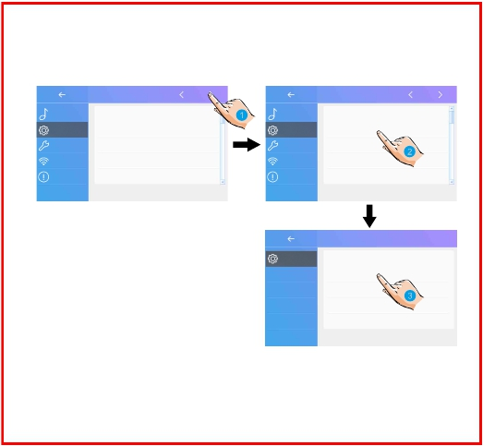

DIP Switcher Set Address
The DIP switches are used to set the user code for each monitor.Total 6 bits can
be configured.
· Bit-1 to Bit-5 are used for user code setting. The value range is from 0 to 31,
which have 32 different codes for 32 apartments.
· When multi monitors need to be installed in one apartment, these monitors
should use the same user code, and the master/slave mode should be set on
the monitor. (Details refer to the section of Setting Slave Monitor)
· Bit-6 is bus line terminal switch, which should be set to “ON” if the monitor is at
the end of bus line, otherwise be set to “OFF”.

Bit-6 switch setting

ON 1 2 3 4 5 6

ON(1)

OFF(0)

ON
=
ON
=

This monitor is assigned with DIP setting instructions.Total 32 DIP codes.

Installer

-20-
Call Tune
General
Installer
Wireless
About
Current addtess
Intercom enable
IPC Setting
Monitor list manage
System settings
[01]
Enable
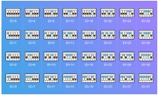

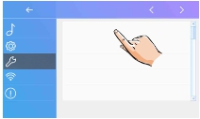

Bit state | Setting | Bit state | Setting
Bit state | When monitoris not at theend of bus line. |  | When monitoris at the end ofbus line.

ON
6

ON
6

Enabling/Disabling intercom function
It’s available to forbid or activate the intercom function.

Installer

Intercom enable

Call Tune
General
Current addtess
Intercom enable
[01]
Enable
Installer
Disable
Enable

Installer
Wireless
About
IPC Setting
Monitor list manage
System settings

*In default setting, intercom function is enable for the monitor.

IPC Setting
It’s available to set the related function of IP camera.

Installer

IPC Setting

Call Tune
General
Installer
Wireless
Current addtess
Intercom enable
IPC Setting
Monitor list manage
[01]
Enable
Installer
Add IPC by searching
Add IPC by manual
IPC list
IPC DHCP

[Enable]

About
System settings

Add IPC by searching: Add the IP camera by searching online.

IPC Setting
IPC searching

Installer
Add IPC by searching
Installer
.......

Add IPC by manual
IPC list

IPC DHCP
[Enable]

-21-
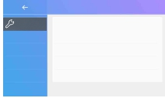

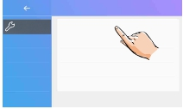

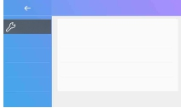

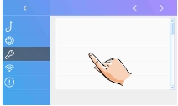

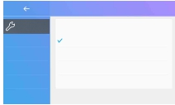

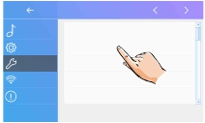

Add IPC by manual: Add the IP camera by manual.

IPC Setting
IPC login

Installer
Add IPC by searching
Add IPC by manual
IPC list
Installer
IPC IP:
User name: admin
User pwd:
admin

IPC DHCP
[Enable]
Channel:
2

Login

IPC list: IP camera list.

IPC Setting
IPC monitor

Installer
Add IPC by searching
Add IPC by manual
IPC edit
IPC delete
[192.168.xxx.xxx] HeroSpeed

IPC list

IPC DHCP
[Enable]

1. Touch it to edit the IP camera's
name.

IPC monitor

IPC monitor

IPC edit
[192.168.xxx.xxx] HeroSpeed
IPC edit

[192.168.xxx.xxx] HeroSpeed

?

IPC delete
IPC delete

2. Touch it to enter delete the IP camera status.
3. Touch it to delete the IP camera.

-22-
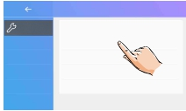

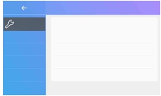

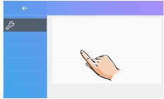

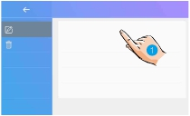

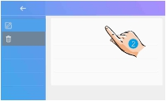

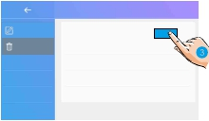

IPC DHCP:It’s available to forbid or activate the IPC DHCP.

IPC Setting
IPC DHCP

Installer
Add IPC by searching
Add IPC by manual
Playlist
Disable
Enable

IPC list

IPC DHCP
[Enable]

Monitor list manage
It’s available to manage the monitor list.

Installer

Mon select

Call Tune
General
Installer
Wireless
About
Current addtess
Intercom enable
IPC Setting
Monitor list manage
System settings
[01]
Enable
Mon select
[X]Door 1
[X]Door 2
[X]Door 3
[X]Door 4
[X]Cam 1

[X] means the function is available;

Mon select

[-] means the function is off and unavailable.
Mon select
[-]Door 1

[X]Door 2
[X]Door 3
[X]Door 4
[X]Cam 1

System setting
This section will be reserve.

-23-
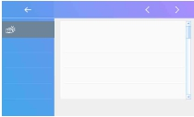

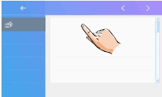

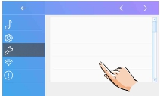

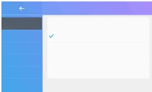

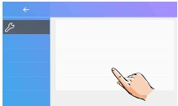

Software upgrade
It’s available to upgrade the device software online/SD card.

Installer
Installer

Call Tune
Current addtess
[01]
Call Tune
FW upgrade

General
Installer
Wireless
About
Intercom enable
IPC Setting
Monitor list manage
System settings
Enable
General
Installer
Wireless
About
Unlock time
Unlock mode
Auto reboot
Reboot
[03]
[Open]
[Enable]

In the FW update interface, users can select

FW update

the Servers/SD card to upgrade.Then touch
"Check" to activate it.
Installer
Server
Download code
Server1[47.91.xx.xx]
847xxx

Check

Unlock time setting
It’s available to set the unlock time.

Installer
Installer

Call Tune
Current addtess
[01]
Call Tune
FW upgrade

General
Installer
Wireless
About
Intercom enable
IPC Setting
Monitor list manage
System settings
Enable
General
Installer
Wireless
About
Unlock time
Unlock mode
Auto reboot
Reboot
[03]
[Open]
[Enable]

-24-

The unlock time can be changed by
yourself at any time. it can be set from
01 to 99 seconds.

Unlock time
08
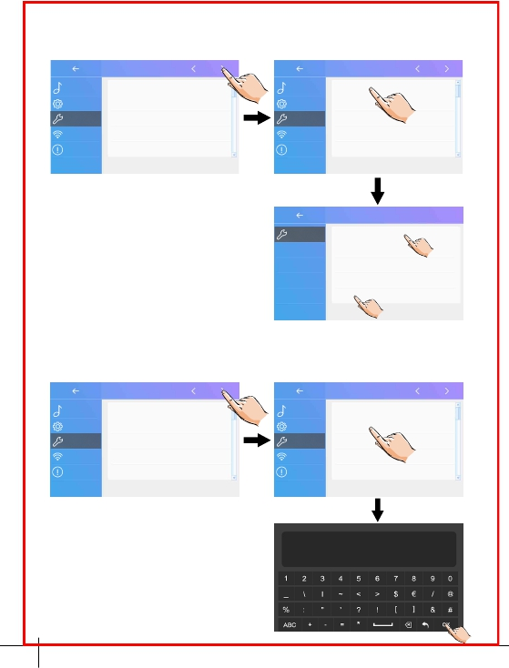

Unlock mode setting
It’s available to set the unlock mode.

Installer
Installer

Call Tune
Current addtess
[01]
Call Tune
FW upgrade

General
Installer
Wireless
About
Intercom enable
IPC Setting
Monitor list manage
System settings
Enable
General
Installer
Wireless
About
Unlock time
Unlock mode
Auto reboot
Reboot
[03]
[Open]
[Enable]

There are two unlock modes: 1.power-

Unlock mode

on- to-unlock type=Open
2.power-off-to-unlock=Close.
Installer
Open
Close

Reboot
It’s available to Auto reboot ,or Reboot the device.

Installer
Installer

Call Tune
Current addtess
[01]
Call Tune
FW upgrade

General
Installer
Wireless
About
Intercom enable
IPC Setting
Monitor list manage
System settings
Enable
General
Installer
Wireless
About
Unlock time
Unlock mode
Auto reboot
Reboot
[03]
[Open]
[Enable]

Installer

Call Tune
FW upgrade

General
Installer
Wireless
About
Unlock time
Unlock mode
Auto reboot
Reboot
[03]
[Open]
[Enable]
?

-25-
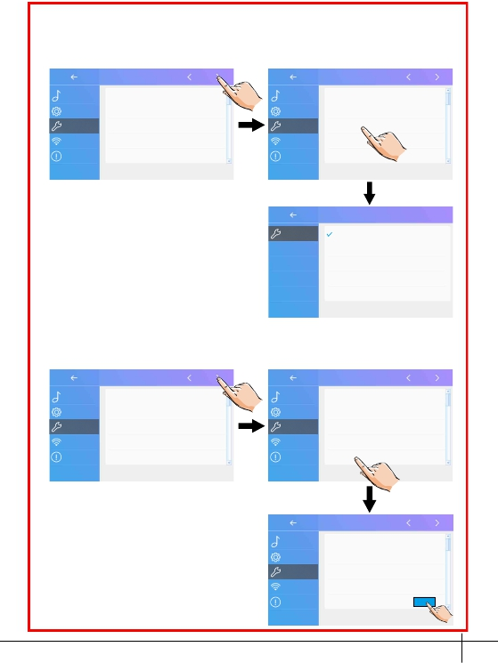

Wireless setting

SD card

WIFI adaptor

Wi-Fi monitor(DX471)

1. Touch it to enter wireless setting

3P-USB cable for
FW updating

Wireless

interface.
Call Tune
General
Wifi switch [ON]
Wlan setting

2. Touch it to activate the function, make
sure the switch is ON.
Installer
Wireless
About
Wireless device regist
SIP config
SIP tools
[00]

3. Touch it to enter wlan setting interface.

4. Touch it to scroll the interface.

Lan setting

5. Touch it to select the domestic network
to which you want to connect the device.
Wireless
Input SSID and PWD
VTKAP03
zhongshi

MagicCyclingGuest
360

6. Touch it to enter the input password

interface.
Wireless
SSID: VTKAP03

PWD:
Auto connect
Connect

-26-
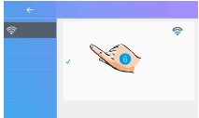

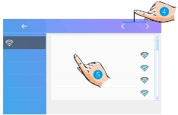

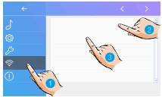

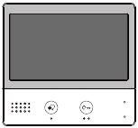

7. Enter the password (if required).

8. Touch it to activate the connection, and
return to Wi-Fi information interface.

9. Go to Connect/Disconnect item.

PWD:
vtk_

Wireless
SSID: VTKAP03

PWD: vtk@123
Connect/Disconnect

Make slave Wi-Fi monitor to be registered with master Wi-Fi
monitor

On master Wi-Fi monitor and slave Wi-Fi monitor, go into wireless setting
interface.

1. Touch it to enter the device manage
interface.

Call Tune
General

Wireless
Wifi switch [ON]
Wlan setting

Installer
Wireless
About
Wireless device regist
SIP config
SIP tools
[00]

-27-
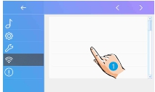

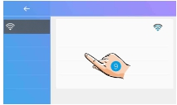

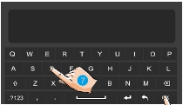

2. Touch it to enter the master / slave register interface.

master Wi-Fi monitor

Device manage

slave Wi-Fi monitor

Device manage

Wireless

Wireless
Register new slave

Master register
My ID: 040019b93fa9/201
Receive slave:
Slave ID:------------ / ---
Wireless

Wireless
Register new master

Slave register
My ID: 040019b83ea9/201
Registered to:
Master ID:------------ / ---

Unegistered
Waiting for Slave's application

SIP config

It’s available to divert the call to mobile while out of home via SIP server.

On the call scene interface

CallScene

1. Touch it to select the divert call mode:
Divert Call If No Answer or Divert Call
Always.
CallScene
Normal Use
No Disturb 8H
No Disturb Always
Divert Call If No Answer

Divert Call Always

-28-
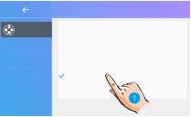

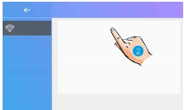

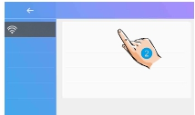

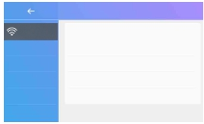

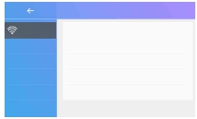

On the wireless setting interface

2. Touch it to enter the SIP config.

Setting

Sip config

Call Tune
General
Wifi switch [ON]
Wlan setting
Wireless
USER NAME
PASSWORD
0e0019axxx
230**

Installer
Wireless
About
Wireless device regist
SIP config
SIP tools
[00]
DOMAIN
Manual registration
Use Default
2easyip.com

Sip config

Sip config

Wireless
USER NAME
PASSWORD
DOMAIN
0e0019axxx
230**
2easyip.com
Wireless
USER NAME
PASSWORD
DOMAIN
0e0019axxx
230**
2easyip.com

Manual registration
Use Default
Manual registration
Use Default

Registered

3. Touch it to restore all settings on “SIP config” and create 2 SIP accounts, one
for DX monitor and one for 2Easy APP. Server will apply to restore two accounts’
password to default, and register it. Only when:
If your DX monitor is not brand new, we suggest you touch “Use default”
before testing.
2Easy APP is not able to register on server

4. Touch it, DX monitor will apply to clean all SIP “contact” on server, and also
will try to register itself to server, with this function it will helps when:
2Easy APP is not able to get push notification.
DX monitor has connect with Wi-Fi, but “Server” icon with “!” or “x” beside.

-29-
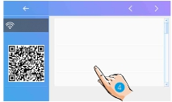

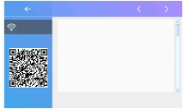

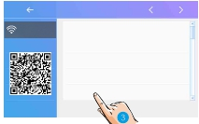

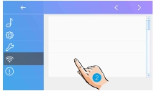

SIP tools

SIP tools could test divert function and with an unattended door station.

1. Touch it to enter the SIP tools page.

Call Tune
General

Wireless
Wifi switch [ON]
Wlan setting

Installer
Wireless
About
Wireless device regist
SIP config
SIP tools
[00]

2. While if your test with pressing door
station doesn’t works well, you could also
try with auto-test.Touch it to enter call
testing page.

Wireless

SIP tools
SIP call testing
SIP call statistics
Clear SIP call statistics
View SIP call logs
Copy SIP call logs to SD

“SIP call testing count” from 1 to 99,
means test automatically 1-99 times;
Set “Call interval” from 1 to 10 min,
means system will wait 1-10 min between
2 calling;
Keep “Retry timing” as default, 12sec

Wireless

Call Testing
SIP call testing count
Call interval
Retry timing
Video quality
Start SIP call testing

[1]
[3min]
[12sec]
[0]

Set “Video quality” to 0, means lowest
required to network;

3. After all settings have done, touch “Start SIP call testing”, DX monitor will
immediately divert a calling to mobile.

-30-
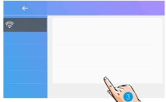

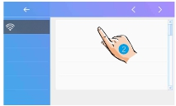

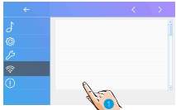

In SIP tools page, you can also know the items "SIP call statistics", "Clear SIP
call statistics", "View SIP call logs", "Copy SIP call logs to SD", "View registered
Phones".

About

1. Touch it to enter about interface.

Setting

Call Tune
General
Installer
Wireless
Device Type:
S/W Ver:
Serial No:
Node ID:
DX471
V1.0.0.171110111114
040019b93333
200

About
IP Address:
192.168.01.100
linked

Device Type: the device name.
S/W Ver: the sofeware version.
Serial No: the device serial number.
Node Id: Node ID number.
IP Address: the device IP address.
H/W Address: the device Mac address.
Subnet Mask: the device subnet mask.
Default Route: the device default route.
DT Address: the device code number.
M/S Code: show the device is a master monitor or sub monitor.
Online: show the numbers of sub monitor.

-31-
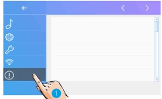

13. Download Setup 2Easy APP

1. Scan and download 2Easy APP, or search “2Easy” on APP store.

IOS

Android

2. Permit “2Easy” with internet access and camera, on DX monitor, press “SIP
Server” icon on main menu, and keep in “SIP config”, on 2Easy APP, press on
top-right, to scan QR code on DX monitor, and press “Save”.

-32-




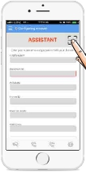

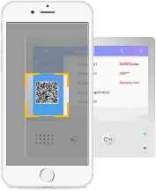

3. Disable “IPV6” on 2Easy APP
Most of internet provide doesn’t support IPV6 feature, please manually disable it
with follow steps:

Press here
to disable

-33-
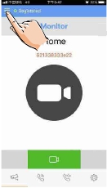

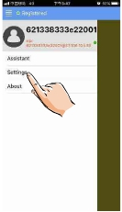

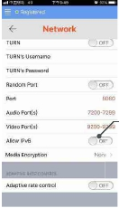

4. After login SIP account on 2Easy APP, check on status bar, or press on the
“Registered” area to manually register, until 2Easy APP display:

14. Surveillance door station via 2Easy APP

On 2Easy APP, press on “Monitor” and wait for a few second (Due to 2-Wire
communication will take around 12 second to get video), blue screen is normally
due to the DX monitor is verifying the password and monitor code.

15. How It Works

Two working modes
There are 2 working modes depend on whether your mobile phone is covered
with same Wi-Fi network or not, and DX master monitor can be regarded as a
gateway device.

-34-
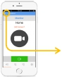

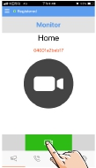

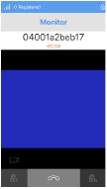

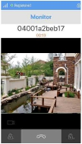

Local mode--at home with same Wi-Fi network
· No need SIP sever and account log in
· Both Wi-Fi sub Monitor and Phone in Local mode work as wireless slave
· monitors
Home router

2-wire System

RFCARD

2

2

PC6A
Wi-Fi master
montior
Wi-Fi sub
monitor
Wireless terminal
(smart phone)

In case of calling, Wi-Fi sub Monitor and Phone will ring simultaneously, one device
answer the call will make others turn off automatically.

Divert mode--away from home with call divert
· SIP server and account are a must(A factory account is preset)

SIP SERVER

2-wire System

RFCARD

2

2

PC6A
Gateway

WIFI/4G
Wireless terminal
(smart phone)

· Call scenes(No disturb / If no answer / Divert always) in away home

Door Station Calling

No Disturb

No rings at all

If No Answer

Slaves Ringing

Mobile Ringing

Divert Immediately

Mobile Ringing

Note: Any one off hook, others will be
closed automatically.

-35-
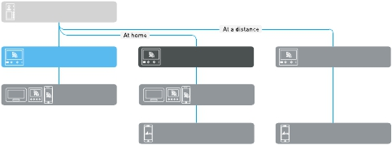

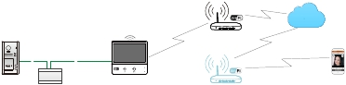

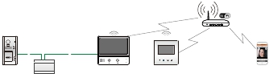

16. Specification

● Power supply:
● Power consumption:
● Monitor screen:
● Display Resolutions:

DC 20~28V
Standby 1.8W; Working 8.16W
7 Inch digital color TFT
800*3(R, G, B) x 480 pixels

● Video signal:
● Wiring:
● Dimension:

1Vp-p, 75Ω, CCIR standard
2 wires, non-polarity
161(H)×174(W)×22(D)mm

17. Precautions

1) All components should be protected from violence vibration. And not allow to
be impacted, knocked and dropped.
2) Please do the cleanness with soft cotton cloth, please do not use the organic
impregnant or chemical clean agent. If necessary, please use a little pure water
or dilute soap water to clean the dust.
3) Image distortion may occur if the video monitor is mounted too close to
magnetic field e. g. Microwaves, TV, computer etc.
4) Please keep away the monitor from wet, high temperature, dust, caustic and
oxidation gas in order to avoid any unpredictable damage.
5) Must use the right adaptor which is supplied by the manufacturer or approved
by the manufacturer.
6) Pay attention to the high voltage inside the products, please refer service only
to a trained and qualified professional.

-36-

Note

-37-

DT-ENG-DX471/TD7-V1

The design and specifications can be changed without notice to the user. Right
to interpret and copyright of this manual are preserved.

